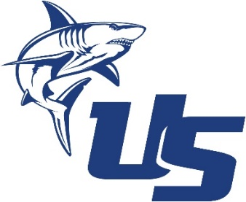
NSU UNIVERSITY SCHOOL
ONLINE ATHLETIC CLEARANCE
- Visit https://www.athleticclearance.com/
- Select Florida
There is a video on the first page to help you with the profile and a help button on the bottom right corner of each screen. This profile must be updated at the beginning of every school year. The FHSAA site is NOT linked to MAGNUS.
- First Time Users:
Create an Account. PARENTS/GUARDIAN will register with a valid email, username (email address) and password.
- Return Users:
Enter login information and click “Sign In”.
- Sign In using the email address you used for registration.
- Select “Start Clearance Here” to start the process.
Return Users:
There is a blue “button” ARCHIVED CLEARANCES. You can retrieve your EL02 from last year’s profile to post on 2023-2024 profile – if it has not expired. Your EL02 is good for one calendar year with the FHSAA.
- Choose:
School Year (2023-2024)
School (NSU University School)
Sport/s (Additional sports can be added throughout the year or added all at once.)
- Complete all required fields for Student Information, Parent/Guardian Information, Medical History, Signature Forms and upload your files (EL02, etc.) Page 4 of the NEW EL02 must be signed/stamped/dated by the physician. The athletic department does NOT need a hard copy of your EL02/physical.
The EL02 form for your physician is available to download on the Medical History page.
- Once you reach the Confirmation Message you have completed the online registration process.
The student is NOT cleared yet! The data is electronically filed with the athletic department for review. You will receive an email when cleared. If the student is not cleared, you will receive an email with the reason for denial and a name/phone number/email to contact if you have questions.
Cindy Hannes
NSU University School
Administrative Assistant, Athletics
954-262-4422
channes@nova.edu

